Church of the Sacred Heart
First Penance and/or First Holy Communion Registration
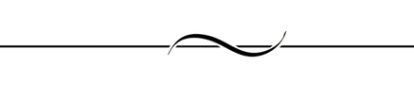
SACRAMENT DATES:
First Penance:
Saturday March 2, 2024 at 10 a.m.

First Communion:
Saturday May 4, 2024 at 10 a.m.
STUDENT INFORMATION
Full Name: ____________________________________________________________ (No nicknames)
Name as you wish it to appear on the First Communion Certificate. (Please Print)
Age on First Communion Day: _____ Male Female
City and State of Birth: ______________________________________________
Date of Birth: ______________________________
Known allergies? (Y/N) ____if yes describe: _________________________________________________
Parent e-mail: ______________________________ Preferred Contact Phone: _____________________
Address: _____________________________________________________________________________
Father’s First and Last Name: ____________________________________________________________
Mother’s First and *maiden* Name: ______________________________________________________
BAPTISM INFORMATION
If not on file, a Baptismal Certificate is REQUIRED if baptized outside of Sacred Heart Parish.
Church of Baptism: ______________________________________________________________
Complete Address: ______________________________________________________________
Baptism Date: _________________________________
VOLUNTEER OPPORTUNITIES Can anyone in your family participate in any of these positions?
Lector Alter Server EM of Communion Usher
OFFICE USE: (Do Not Complete) Date received: ____________ Baptism Certificate: On File / Received

