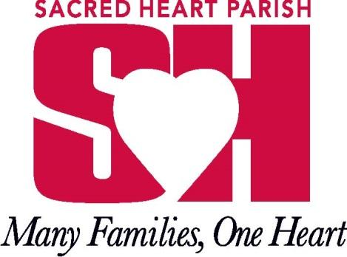
203 Church Road
Oxford, Pennsylvania, 19363
E-Mail: faithformation@sacredheart.us
(610) 932- 5040
Faith Formation Office

Dear Parent(s)/Guardian(s),
Congratulations! Your child(ren) will be receiving their First Holy Communion on Saturday, May 4th at 10:00am. As we arrive closer to that day, Father Shenosky would like to share some information with you and your child(ren) regarding the Eucharist in the Mass. The following excerpt, written by Father Shenosky himself, can be found in the Altar Server Handbook and discusses the dogmatic theology of the Eucharist:
“The Holy Sacrifice of the Mass is the source and summit of the whole Christian life (cf. Lumen Gentium, #11). The Mass re-presents (i.e, makes present again), in an unbloody and sacramental manner, the Sacrifice of Jesus Christ on the Cross. In fact, the whole Paschal Mystery – Our Lord’s Passion, Death, and Resurrection – is made present for us so that we may participate in the very mystery by which we have been saved. Furthermore, the Holy Eucharist is a participation in the heavenly liturgy. During the Holy Mass, through the power of the Holy Spirit and the sacred power that the priest receives at his ordination, at the consecration the bread and wine become the Body and Blood, Soul and Divinity of Jesus Christ. The Catholic Church calls this change Transubstantiation.”
We, the Faith Formation Team, are very excited for you and your child(ren) as they prepare to receive Jesus Christ in the Sacrament of First Holy Communion. A few reminders to teach your child(ren) about receiving the Eucharist:
- The Church requires fasting from all solid foods (including chewing gum) and liquids except for water (which can be taken at any time), and medicine at least one hour before receiving the Eucharist during Mass.
- The Catholic Church allows for the reception of Holy Communion either on the tongue (the more traditional way) or in the hand.
- If one is receiving on the tongue, the person should open their mouth and put out their tongue for the priest/deacon/Communion Minister to place the sacred Host on the tongue. The communicant should then consume the sacred Host immediately.
- If one is receiving on the hand, the person should make a throne with their hands, placing their left hand over their right hand. The priest/deacon/Communion Minister will place the Host in the left hand. The communicant should then immediately take the sacred Host with their right hand, and place the Host in their mouth, consuming the Host.
If you have any questions, please feel free to call the office at 610-932-5040 or email me at awitiak@sacredheart.us!

God bless,
Alexis Witiak
Director of Religious Education

